Ethernet Services over OTN Interoperability Steps Closer to Reality
By: Jim Jones, Optics Products and Solutions Marketing Manager, Alcatel-Lucent
Categories: Article Archive | Tags: Ethernet, interoperability, OIF, optical, OTN
http://www2.alcatel-lucent.com/blogs/techzine/2012/ethernet-services-over-otn-interoperability-steps-closer-to-reality/

Recent standards enhancements enable successful global network interoperability demonstration of Ethernet Services over OTN that supports multivendor data plane and control plane interworking.

Highlights
- Updates to OTN data rates and mapping formats make it the ideal transport technology for Ethernet and packet clients from 1 Gb/s to 100 Gb/s
- Optical control plane key to unlock dynamic networking potential of OTN
- Interoperability testing proves rollout of Ethernet Service over OTN transport as possible and essential for network convergence
The need – efficient transport of Ethernet
Ethernet has long been the dominant interconnect technology in many forms of access networks and Local Area Networks (LANs). While Ethernet is widely supported, mature and economical, a different transport medium is usually needed to carry high volumes of Ethernet traffic over long distances. The Optical Transport Network (OTN) hierarchy defined in ITU-T Recommendation G.709 is the leading choice among carriers to provide high-capacity, long reach transport — not just for Ethernet clients, but virtually any client. OTN was initially defined around the data rates and management techniques of Synchronous Digital Hierarchy/Synchronous Optical Networking (SDH/SONET), with the addition of a photonic layer for wavelength management. The ITU-T recently defined enhancements to OTN that broadened its appeal by making it more beneficial to Ethernet and packet clients, including:
- Aligning OTN payload rates to cover all Ethernet rates between 1 GigE and 100 GigE
- Creating a flexible-sized optical container (ODUflex) to match the optical bandwidth to the client demand
- Defining adaptation methods best suited for packet client transparency
Previously, transporting some types of Ethernet services over OTN required proprietary techniques that impeded vendor interoperability and reduced network efficiency. The recent updates to OTN lowered these barriers, making OTN the clear choice for Ethernet transport.
The term “OTN” is often used to refer to electrical switching layers. In fact, the OTN hierarchy includes both electrical (the Optical Data Unit or ODU) and photonic (the Optical Channel or OCh) switching layers, as shown in Figure 1 .
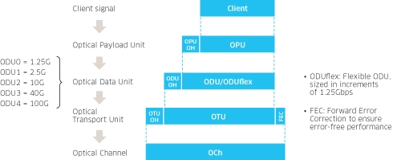
Figure 1. OTN hierarchy
Until recently, equipment to support both ODU and OCh layers was usually packaged into two network elements (NEs) — one for electrical switching functions and another for photonic transport on a Dense Wavelength Division Multiplexer (DWDM) or Reconfigurable Optical Add/Drop Multiplexer (ROADM). These switching functions are increasingly being combined into a single converged NE powered by an optical control plane.
Communication service providers (CSPs) are extensively deploying OTN transport equipment to take advantage of its flexibility, transparency, efficiency and carrier-class performance. Many of these CSPs are also using intelligent control planes to simplify network operation, accelerate service delivery and enhance resiliency. But CSPs also need confidence that migration to control plane-enabled OTN is interoperable across a wide range of vendors.
The goal – multivendor interoperability
The need for interoperable components and network equipment drives the work of the Optical Internetworking Forum (OIF). The OIF uses and extends the work of industry standards groups to produce Implementation Agreements (IAs) aimed at multivendor interoperability. The OIF periodically holds interoperability demonstrations that offer a proof-of-concept staging ground for products that use OIF IAs and related technologies. OIF recently completed a demonstration of Ethernet Services over OTN Transport and showcased it at OFC-NFOEC. The testing, which covered both data plane and control plane objectives, included eight equipment and software vendors in four leading carrier labs, as shown in Table 1.
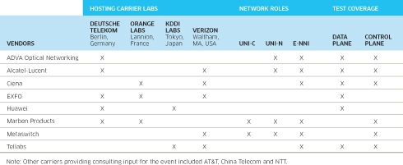
Table 1: OIF Demonstration Carriers and Vendors
By locating the equipment in CSP labs instead of a third-party demonstration lab, the OIF demonstrations put the equipment into the hands of the end users — the CSPs that will deploy it. This environment also brings together competing vendors to collaborate and test products based on the latest standards.
The network – Ethernet Service over OTN Transport
The OIF uses the Automatically Switched Optical Network (ASON) architecture defined by ITU-T and Generalized Multi-Protocol Label Switching (GMPLS) protocols defined by IETF. The ASON architecture allows carriers to partition networks into domains, enabling scalability, security and interworking between different vendors or technologies. ASON supports the following interfaces:
- User-Network Interface (UNI): A service activation interface, where a client requests connection services from a transport network. The UNI includes both a client side (UNI-C) and a network side (UNI-N). The UNI supports a signaling protocol between a client and the network. Because ASON does not allow the client to have visibility into the network topology, the UNI does not include a routing protocol.
- External Network-Network Interface (E-NNI): A service control interface between network domains. These domains contain nodes grouped together by vendor, by technology type or by carrier administrative unit. The E-NNI includes both signaling and routing protocols.
Within each domain, there may be an Internal Network-Network Interface (I-NNI), with signaling and routing between nodes in the domain, but the I-NNI is not standardized.
Figure 2 shows the different reference points in a hypothetical Ethernet over OTN network.
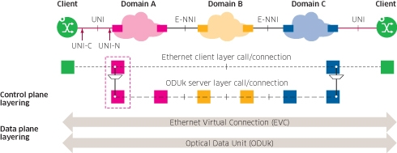
Figure 2. Ethernet over OTN data and control plane
Equipment at each of the reference points has different responsibilities, as summarized in Table 2.
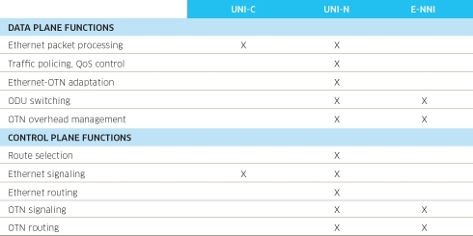
Table 2. Data and control plane functions of UNI-C, UNI-N and E-NNI
As a gateway between the packet (Ethernet) and optical (OTN) layers of the network, the UNI-N performs the most crucial and demanding role in this network. The UNI-N not only separates Ethernet and OTN layers, it also separates client and network spaces. It must ensure Ethernet flows are properly mapped to ODU containers, and that the OTN route chosen through the network will meet the Ethernet client service requirements. While these requirements increase the challenge to implement the UNI-N domain, they also make it easier for the simpler UNI-C nodes and E-NNI transit domains to participate in the network.
The testing – leading up to OFC-NFOEC
Data plane testing between vendors was performed within each of the four CSP labs. Data plane testing typically demonstrates whether:
- Different vendors’ physical interfaces are compatible
- Traffic can be passed between vendors without errors or dropouts
- Operations Administration and Maintenance (OAM) functions carried in overhead bytes operate correctly
Key data plane test objectives for this event included:
- Mapping of partial and full-rate 1 GigE and 10 GigE client interfaces into OTN payloads, using different adaptation techniques
- Interoperability of OTU2 and OTU3 (10 Gb/s and 40 Gb/s OTN payload) interfaces between vendor domains
- OTN multiplexing, switching and layered overhead functions
Control plane testing was performed initially within each CSP lab, then between the labs. The labs were interconnected by a global Signaling Control Network (SCN) that allowed full pair-wise testing of all vendors, regardless of location. Control plane testing focused on the ability of connections to be set up, managed, modified and torn down by distributed optical control plane protocols, rather than through centralized network management systems. Key control plane objectives included:
- Single and multi-layer connection service activation
- Control for 1 GigE and 10 GigE Ethernet clients mapped to either OTU2 or OTU3 network interfaces
- Switched connections (activated by signaling between UNI-C and UNI-N)
- Soft permanent connections (activated by management command to the ingress UNI-N)
- Support of two service levels (unprotected connections and connections with dynamic intra-domain service recovery)
The global SCN enabled control plane testing across all the labs and domains. During the event, real-time topology display software showed the current state of the network connections. An example of the test topology display is shown in Figure 3.
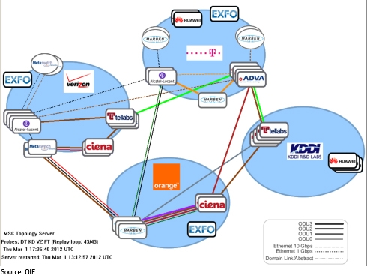
Figure 3. Real-time control plane test topology
This particular test case covered nine simultaneous connections covering all control plane vendors. In the figure, each end-to-end connection has a different color so connections can be distinguished. The thickness of each solid line reflects the speed of the OTN interface, and the dotted lines show the Ethernet connections. The ovals represent UNI-C client nodes. The nodes without connections through them participated in data plane testing only.
The outcome – multivendor interoperability and lessons learned
The goal of OIF interoperability events is to test interworking between vendor equipment and carrier labs. But it’s a long road to achieve interoperability and along the way obstacles are frequently encountered, such as:
- Different implementation options: Technical specifications may allow multiple ways to implement a function — and if two vendors choose different options, they may both meet the specification but not interoperate.
- Gaps or ambiguities in specifications: Vendors may interpret the specifications in different ways when there are gaps or unclear requirements.
- Errors in specifications or in vendor implementations: The technical specifications may have errors or vendor products may have implementation errors that need to be corrected.
This year’s OIF demonstrations revealed barriers of each kind, which were overcome as testing proceeded. The event was considered a success, as vendors and carriers were able to interoperate and deliver Ethernet Services over OTN Transport. One of the most important outcomes was a set of lessons learned that will reduce or remove the barriers listed above. The lessons will provide valuable feedback into specifications owned not only by OIF, but also by other industry groups such as IETF and ITU-T. Over the next few months, OIF will document and share technical lessons learned and update its own control plane specifications.
The next steps – a smoother road to deployment
For quite some time, Ethernet services have been delivered over OTN transport networks, but the OIF demonstration and recent updates to the specifications have made this an even more compelling approach. Earlier implementations may have used proprietary techniques or did not leverage the synergy between the latest data plane and control plane capabilities. Some of the control plane specifications are in their final stages before ratification and the lessons learned from this event will be folded in before they are completed.
Each of the participating companies in the OIF demonstration committed significant time and resources to the event. Their commitment shows the importance of this technology to next-generation transport networks. In the process, demonstration participants gained a crucial head start in implementing the technology and making it operational.

